signInAuthenticationFailed1659013462925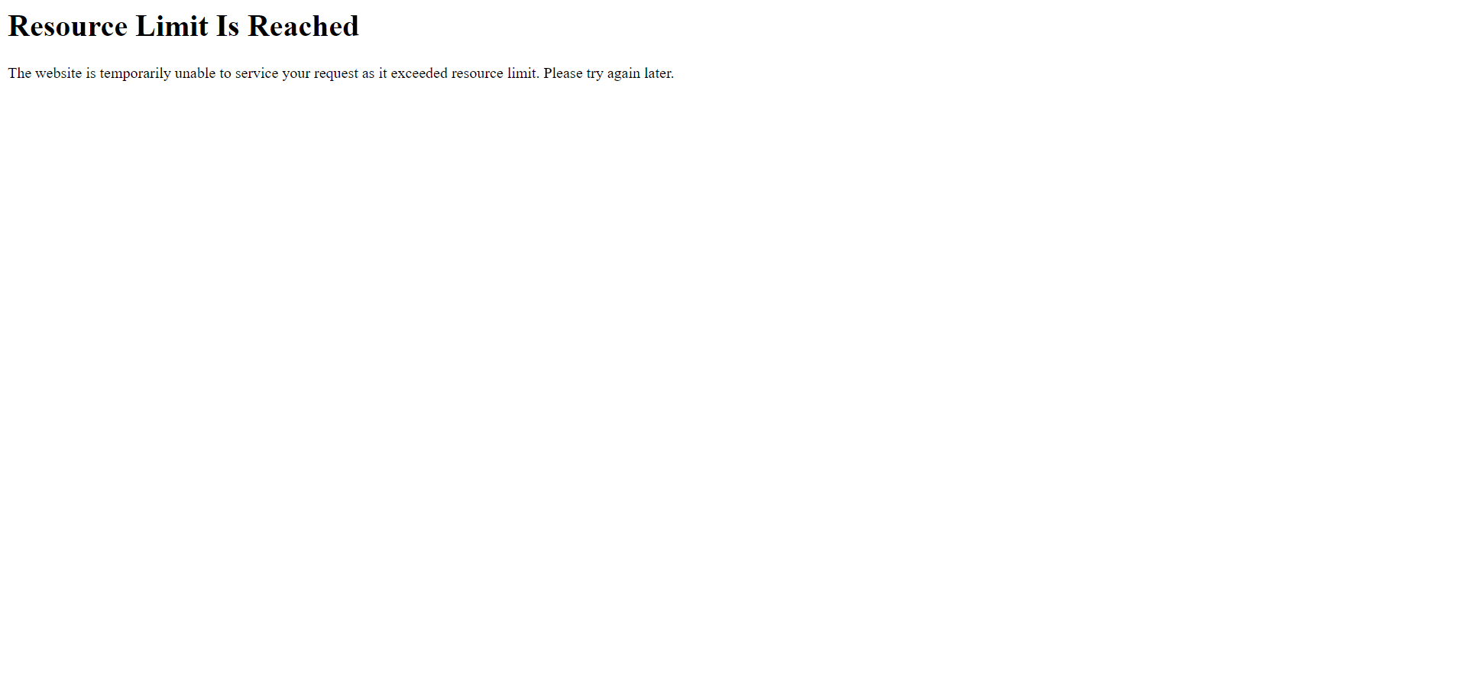

signInEmailInvalido1659013468736